Pharmacology CNS Basic

I. General Pharmacology
Pharmacokinetics and Pharmacodynamics
Pharmacology is broadly divided into General Pharmacology and Systemic Pharmacology. General Pharmacology includes Pharmacokinetics and Pharmacodynamics, which describe the interaction between the body and drugs at a fundamental level.

A. Pharmacokinetics: What the Body Does to the Drug (ADME)
Pharmacokinetics is the study of how the body handles a drug. It is summarized by the acronym ADME:
- Absorption: This is the process by which a drug enters the bloodstream from its site of administration.
- Famous Sites of Absorption: Gastrointestinal tract (oral medications), lungs (inhalers/nebulizers), oral cavity mucosa (e.g., chewing tobacco), vaginal and rectal mucosa.
- Intravenous (IV) Administration: They are directly introduced into the bloodstream, bypassing the absorption phase, which makes them the fastest route to achieve bioavailability but technically not "absorbed."
- Factors Affecting Absorption/Diffusion:
  - Solubility: Lipid-soluble drugs are absorbed faster than water-soluble drugs because cell membranes are lipid bilayers. Water-soluble drugs require external receptors or carriers.
  - Polarity, Size, and Charge: These factors determine a drug's solubility and thus its route of administration. Charged (ionic) and polar compounds are water-soluble.
  - Surface Area: Larger surface area (e.g., lungs, intestines) increases diffusion.
  - Temperature: Higher temperature increases diffusion.
  - Molecular Size: Smaller molecules diffuse faster.
  - Membrane Thickness: Thinner membranes allow faster diffusion.
- Types of Transport Across Membranes:
  - Passive Transport (Diffusion): No energy (ATP) required, moves along the electrochemical gradient (high to low concentration). Includes simple diffusion, osmosis (for water), and facilitated diffusion (requires a carrier protein).
  - Active Transport: Requires energy (ATP), moves against the gradient (low to high concentration).
  - Facilitated Diffusion: When a carrier protein is required (facilitated diffusion, active transport).
- Distribution: The process of the drug moving from the blood to the tissues.
- Plasma Proteins: Lipid-soluble drugs, being water-insoluble, require carrier proteins (e.g., albumin, globulin) to transport them in the blood. Water-soluble drugs "float freely in the blood" without carriers.
- Free vs. Protein-Bound: Only the "free" (unbound) portion of a drug is active; protein-bound drugs are inactive.
- Metabolism (Biotransformation): The process by which the drug's chemical structure is altered, usually in the liver.
- Liver Enzymes (P450 System): A key system for drug metabolism.
- Outcomes of Metabolism:
  - Active drug to inactive drug (most common, e.g., acetaminophen).
  - Inactive prodrug to active drug (e.g., Isoniazid).
  - Active drug to even more active drug (e.g., morphine to morphine-6-glucuronide).
  - Active drug to toxic metabolite.
- Elimination (Excretion): The removal of the drug and its metabolites from the body.
- Primary Routes: Kidney (urine), biliary system (stool).
- Other Routes: Sweat, breath.

B. Pharmacodynamics: What the Drug Does to the Body
Pharmacodynamics is the study of the effects of drugs on living organisms. It focuses on the drug's mechanism of action and the resulting physiological changes.
- Receptors: Drugs interact with specific receptors in the body.
- Water-soluble drugs: Receptors are typically "on the outside" (external) of the cell membrane because the drug cannot cross the lipid bilayer. These are "rapidly acting."
- Lipid-soluble drugs: Receptors are typically "on the inside" (cytoplasmic, or nuclear) because the drug can "travel through" the cell membrane. These often lead to "genomic action" (affecting DNA/genes) and are "slowly acting."
- Mechanism of Action: When a drug binds to its receptor, it can:
  - Open or close ion channels.
  - Stimulate or inhibit pumps.
  - Initiate genomic actions.
- Affinity: It's the strength of the binding between a drug and its receptor.
- Agonists vs. Antagonists:
- Agonist: Binds to a receptor and produces a biological effect.
  - Full Agonist: Produces "100% of the desired effect."
  - Partial Agonist: Produces "something between zero and 100" of the desired effect.
- Antagonist: Binds to a receptor but blocks the action.
  - Example: Beta-blockers (beta antagonists) block sympathetic beta receptors. This doesn't directly lower heart rate but removes sympathetic stimulation, allowing the parasympathetic nervous system to predominate and lower heart rate.
- Inverse Agonist (Super Antagonist): Produces the "negative or the opposite effect" of an agonist.
- Efficacy and Potency: Further concepts in pharmacodynamics that describe the maximum effect a drug can produce (efficacy) and the amount of drug needed to produce an effect (potency).

II. Systemic Pharmacology: Drugs and Body Systems
Systemic pharmacology deals with drugs acting on specific organ systems.

A. Autonomic Pharmacology
The Autonomic Nervous System (ANS) is "automatic," meaning involuntary. It consists of:
- Sympathetic Nervous System: "Fight flight." Responsible for increasing heart rate and force, bronchodilation, pupil dilation, increasing blood pressure, and diverting blood to skeletal muscles. Inhibits digestion and urination.
- Parasympathetic Nervous System: "Rest and digest." Responsible for lowering heart rate, bronchoconstriction, pupil constriction, increased saliva and digestive secretions, and promoting digestion and urination.
- Enteric Nervous System: Controls the gut, part of the autonomic system (myenteric plexus for motility, submucosal plexus for secretions).

B. Neuropharmacology (Central Nervous System)
Deals with drugs affecting the brain and spinal cord.
- Neurotransmitters:
  - Excitatory: Glutamate, Aspartate. Cause depolarization (activation).
  - Inhibitory: GABA, Glycine. Cause hyperpolarization (inactivation) by allowing negative ions (e.g., chloride) to enter neurons or positive ions (e.g., potassium) to leave.
- Examples of Mechanisms:
  - Sedatives/Hypnotics (e.g., Benzodiazepines, Barbiturates): Act on GABA receptors to open chloride channels, leading to chloride influx, hyperpolarization (sedation/hypnosis).
  - Opioids (e.g., Morphine): Act on Gi-coupled receptors, opening potassium channels, leading to potassium efflux, hyperpolarization, and inhibition of pain.

C. Cardiac Pharmacology
Addresses conditions like arrhythmias, hypertension, angina, hyperlipidemia, and heart failure.
- Positive Inotropes: Boost cardiac contractility (e.g., Digoxin).
- Negative Chronotropes: Lower heart rate.
- Diuretics: Medications that "tell the kidney to pee more in order to lose more fluid and lower my blood pressure."

D. Chemotherapy (Anti-Cancer Pharmacology)
Targets cancer cells, often by interfering with the cell cycle (G1, S, G2, M phases).
- Cell Cycle Specific: Target specific phases (e.g., antimetabolites target S phase, leading to side effects like hair loss, GI distress, bone marrow suppression (pan-cytopenia) in rapidly dividing cells).
- Cell Cycle Non-Specific: Affect cells regardless of their cycle phase.
- Classes of Chemotherapy: Antimetabolites, alkylating agents, plant alkaloids, antibiotic chemotherapy, hormones, immunotherapy, targeted therapy.

E. Antibiotics (Antimicrobials)
Umbrella term for "anti-microbials," including antibacterial, antifungals, antivirals, and antiparasitic medications.
- Bactericidal vs. Bacteriostatic:
  - Bactericidal: "medication will kill the bacteria."
  - Bacteriostatic: "it's not going to kill the bacteria but it will hinder its replication."
- Gram Staining: Classifies bacteria based on peptidoglycan cell wall thickness and stain retention (Gram-positive: thick wall, retains purple; Gram-negative: thin wall, stains pink).
- Synergy: "1 + 1 = 3," where the combined effect of two drugs is greater than the sum of their individual effects (e.g., Penicillin + Aminoglycosides).
- Additive Effect: "1 + 1 = 2," combined effect is the sum of individual effects (e.g., Loop Diuretics + Aminoglycosides for ototoxicity).
- Antagonistic Effect: One drug opposes the action of another, or the combined effect is less than expected (e.g., Penicillin + Tetracycline).
- Mechanisms of Action: Cell wall synthesis inhibitors, cell membrane disruptors, protein synthesis inhibitors (30S or 50S ribosomes), nucleic acid synthesis inhibitors.

Pharmacology of CNS and Psychotropic Drugs
1. Classification of Psychotropic Drugs
Psychotropic drugs are defined as "those that affect mood and behavior." Let’s categorizes them into eight main groups based on their primary effects and clinical applications:
- Anxiolytics and sedatives: Synonyms include hypnotics and minor tranquilizers. These drugs "cause sleep and reduce anxiety." Examples are barbiturates and benzodiazepines.
- Antidepressant drugs: Defined as drugs that "lessen the symptoms of depressive illness." Examples include monoamine oxidase inhibitors, tricyclic antidepressants, and selective serotonin reuptake inhibitors.
- Antipsychotic drugs: Also known as neuroleptic drugs, anti-schizophrenic drugs, or major tranquilizers. These are "effective in relieving the symptoms of schizophrenic illness." Examples include clozapine and haloperidol.
- Analgesic drugs: Used clinically for "controlling pain," with opioid analgesics given as an example.
- Psychomotor stimulants: Also known as psychostimulants. These drugs "cause wakefulness and euphoria." Examples include amphetamine, cocaine, and caffeine.
- Anaesthetic agents: Drugs "used to produce surgical anaesthesia." Halothane and propofol are examples.
- Psychomimetic drugs: Synonyms are hallucinogens and psycho-dysleptics. These drugs "cause disturbance of perception (particularly visual hallucinations) and of behaviour in ways that cannot be simply characterised as sedative or stimulant effects." Examples include lysergic acid diethylamide, mescaline, and phencyclidine.
- Cognition enhancers: Also called nootropic drugs. These "improve memory and cognitive performance." Examples include acetylcholinesterase inhibitors (e.g., donepezil) and NMDA receptor antagonists (e.g., memantine).

1. Chemical Signaling in the Nervous System
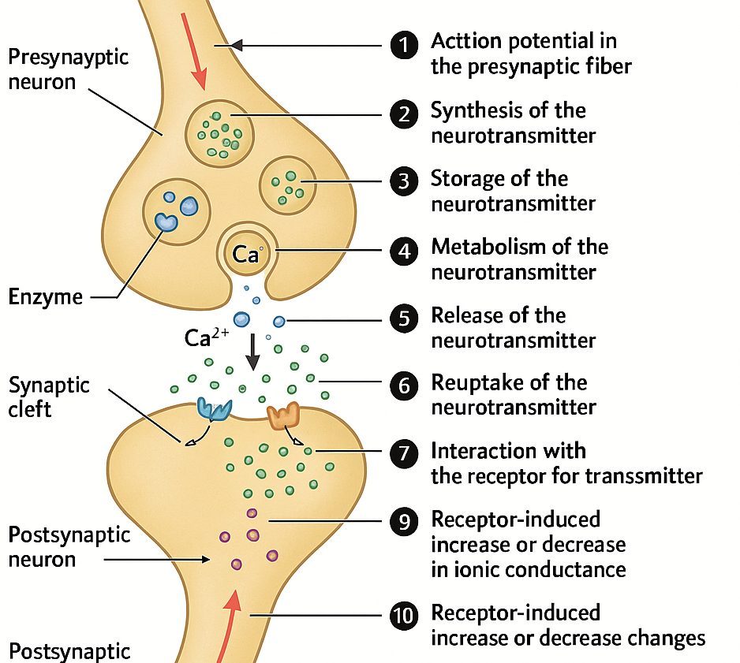
Drug action within the nervous system primarily targets synaptic transmission. The source outlines ten steps where drugs can alter this process:
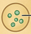
- Action potential in the presynaptic fiber
- Synthesis of the neurotransmitter
- Storage of the neurotransmitter
- Metabolism of the neurotransmitter
- Release of the neurotransmitter
- Reuptake of the neurotransmitter

- Degradation of the neurotransmitter
- Interaction with the receptor for the transmitter
- Receptor-induced increase or decrease in ionic conductance
- (Implied: Downstream effects of ionic conductance changes)

2. Types of Receptors in the CNS
The CNS utilizes different types of receptors to mediate neuronal communication:
- Voltage-gated ion channels: These channels have a "voltage sensor component of the protein [that] controls the gating of the channel." Their opening and closing are regulated by changes in membrane potential.
- Ligand-gated ion channels (Ionotropic receptors): In these channels, "the binding of the neurotransmitter to the ionotropic channel receptor controls the gating of the channel." Examples are Nicotinic (acetylcholine) and GABA-A receptors, where neurotransmitter binding directly opens or closes an ion channel, leading to rapid changes in ion flow.
- Metabotropic receptors (G protein-coupled receptors): These are more complex and have two types described:
  - Type A: When bound by a ligand, this receptor "activates a G protein that then interacts directly with an ion channel." The Cardiac Muscarinic Acetylcholine receptor activating K+ channels is given as an example”.
  - Type B: Upon binding, this receptor "activates a G protein that then activates an enzyme." This activated enzyme "generates a diffusible second messenger, e.g., cAMP, which interacts with an ion channel," leading to more prolonged and widespread cellular effects.

3. Blood-Brain Barrier (BBB)
The BBB is a critical protective mechanism in the CNS:
- It is a "protective functional separation of the circulating blood from the extracellular fluid of the CNS that limits the penetration of substances, including drugs."
- Permeability: Generally, "only small non-polar molecules can diffuse passively across cell membranes" of the BBB. Many essential "nutrients, such as glucose and the essential amino acids, have specific transporters that allow them to cross the BBB."
- Role of Transporters: Many substances utilize transporters, which can either "facilitate entry into the brain or reduce it by pumping the compound from the endothelial cell interior back into the bloodstream."

4. Central Neurotransmitters
Central neurotransmitters are chemical messengers that transmit signals across synapses in the CNS. The main categories include:
- Amino acids:
  - Acidic amino acids (Excitatory Amino Acids, EAAs): Glutamate and Aspartate. These are potent modifiers of neuronal excitability, primarily causing excitation. Glutamate, for example, interacts with four types of receptors (three ionotropic and one metabotropic).
  - Neutral amino acids (Inhibitory Amino Acids): GABA and Glycine. These are potent modifiers of neuronal excitability, primarily causing inhibition.
- Acetylcholine: A widespread neurotransmitter involved in various functions.
- Monoamines: Norepinephrine, Dopamine, and 5-HT (Serotonin). These play critical roles in mood, cognition, and motor control.
- Peptides: A diverse group of neurotransmitters with various functions.
- Nitric oxide: A gaseous neurotransmitter with unique signaling properties.
- Purines: Such as adenosine, which act as neurotransmitters.
All these compounds are present in high concentrations in the CNS and significantly influence neuronal activity.

The role of glutamate as a central neurotransmitter
Glutamate is a critical excitatory amino acid (EAA) neurotransmitter in the CNS. It is highly abundant and plays a crucial role in most fast excitatory synaptic transmission. Glutamate exerts its effects by interacting with four main types of receptors: three are ionotropic (ligand-gated ion channels), and one is metabotropic (G protein-coupled).
When glutamate binds to its receptors, it typically leads to an influx of positive ions into the postsynaptic neuron, making it more likely to fire an action potential. This excitatory action of glutamate is fundamental for various brain functions, including learning, memory formation, and synaptic plasticity.

I. Neuronal Communication: The Foundation
The brain operates through a complex network of cells called neurons, which communicate with each other and with the rest of the body. This communication is essential for perception and bodily functions.
- Electrical and Chemical Signals: Within a neuron, signals are transmitted via electrical "Action potentials." However, at the axon terminal (the end of the neuron), this electrical signal is converted into a chemical signal through the release of neurotransmitters.
- The Synapse: The space between neurons is called the synapse. Neurotransmitters are released into this space and then bind to specific receptors on the dendrite (signal-receiving end) of an adjacent neuron.
- Receptor Specificity: Each neurotransmitter has a "respective receptor" it binds to. For example, "dopamine would bind to a dopamine receptor." This binding propagates the signal into the new neuron, which can be either "excitatory or inhibitory" depending on the receptor type.
- Reuptake: After transmitting the signal, neurotransmitters are reabsorbed out of the synapse in a process called reuptake.

II. Drugs and Neurotransmitter Balance
The synapse is a critical site where many drugs exert their effects. Drugs can be used therapeutically to restore balance when natural signaling is disrupted (e.g., "either too little signal or too much signal").
Drugs affecting neurotransmitters are categorized into three main types:
A. Agonists
- They mimic or enhance the natural action of a neurotransmitter.
- Example: Morphine: Morphine is an agonist for Endorphin neurotransmitters. Normally, endorphins produce a "happiness sensation." Morphine "bind[s] to the exact same receptor as the endorphins and they'll cause the same effect on the neuron," leading to a similar "happiness sensation" or "high."
B. Antagonists
- They block or inhibit the action of a neurotransmitter.
- Mechanism: They bind to the neurotransmitter's receptor but "does not cause a signal." Instead, they prevent the natural neurotransmitter from binding and activating the receptor, thus blocking its effect.
- Example: Atropine: Atropine is an antagonist of Acetylcholine. Acetylcholine typically causes an "excitatory signal" for "movement." In conditions like Parkinson's disease, "too much signaling of acetylcholine" can lead to "muscle shaking or Tremors." Atropine "prevent[s] the acetylcholine from binding" to its receptor, thereby “counteracting the excessive movement.
C. Reuptake Inhibitors
- Reuptake inhibitors "prevent the reuptake" of neurotransmitters from the synapse.
- Mechanism: By blocking the reabsorption process, these drugs keep neurotransmitters in the synapse for a longer duration, leading to prolonged activation of receptors and an intensified effect.
- Example: Cocaine: Cocaine is a reuptake inhibitor of Dopamine. Dopamine normally produces a "very happy sensation." Cocaine "block[s] that reuptake," leading to "very very high levels" of dopamine in the synapse.

III. Key Properties of Neurotransmitters
The properties defining a chemical as a neurotransmitter include:
- Synthesis: Must be synthesized in the presynaptic neuron.
- Localization: Localized to vesicles in the presynaptic neuron.
- Release: Released from the presynaptic neuron under physiological conditions.
- Removal: Rapidly removed from the synaptic cleft by uptake or degradation.
- Receptor Presence: Presence of receptors on the postsynaptic neuron.
- Biological Response: Binding to the receptor elicits a biological response.

IV. Neurotransmitters vs. Neuromodulators
While both are chemical messengers released by neurons, there are distinct differences:
- Neurotransmitters:
  - Released at anatomically specialized junctions (synapses).
  - Diffuse across a narrow cleft to affect one or two postsynaptic neurons, muscle cells, or other effector cells.
  - Examples include Acetylcholine, Glycine, Norepinephrine, and Serotonin.
- Neuromodulators:
  - Released from a neuron in the central nervous system or periphery.
  - Affect groups of neurons or effector cells that possess appropriate receptors.
  - May not be released at synaptic sites.
  - Often act through second messengers and can produce long-lasting effects.
  - Their release can be local or more widespread.
  - Examples include Opioid peptides, nitric oxide, and cannabinoids.

V. Classification
The document provides detailed information on several key neurotransmitters and neuromodulators:

1. Acetylcholine (ACh)
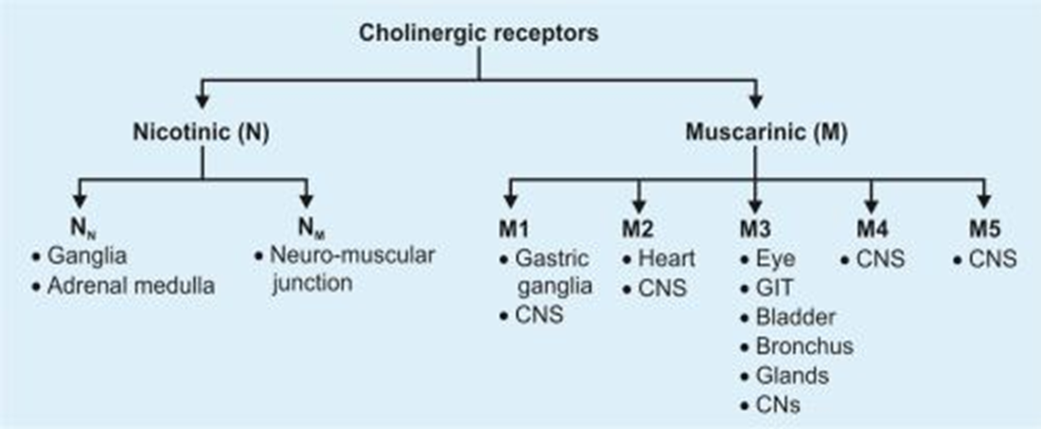
- Discovery: The first neurotransmitter discovered in 1921 by Otto Loewi, initially named "vagusstoff."
- Structure: An ester of choline and acetic acid.
- Distribution: Widely distributed.
- Receptors:
  - Muscarinic (M1, M2): Metabotropic (G protein-coupled). M1 is excitatory (e.g., ↓ K+ conductance, ↑ IP3, DAG), M2 is inhibitory (e.g., ↑ K+ conductance, ↓ cAMP). Antagonists include Atropine.
  - Nicotinic: Ionotropic. Excitatory (↑ cation conductance). Antagonists include Dihydro-β-erythroidine.

2. Dopamine (DA)
- Precursor: Precursor to norepinephrine; predominant catecholamine in the CNS.
- Functions: Plays roles in motivation and reward (many drugs of abuse increase DA signaling), motor control, and hormone release.
- Receptors:
  - D1 and D5: Excitatory (↑ cAMP).
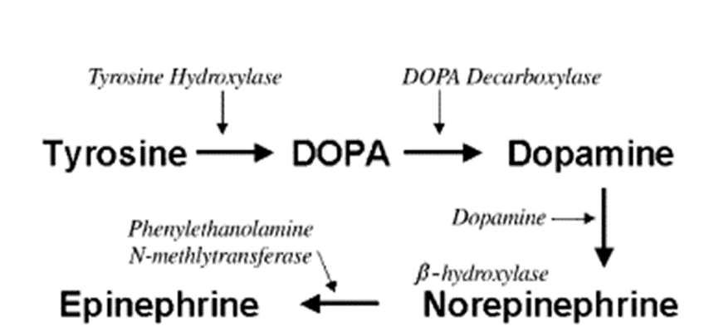
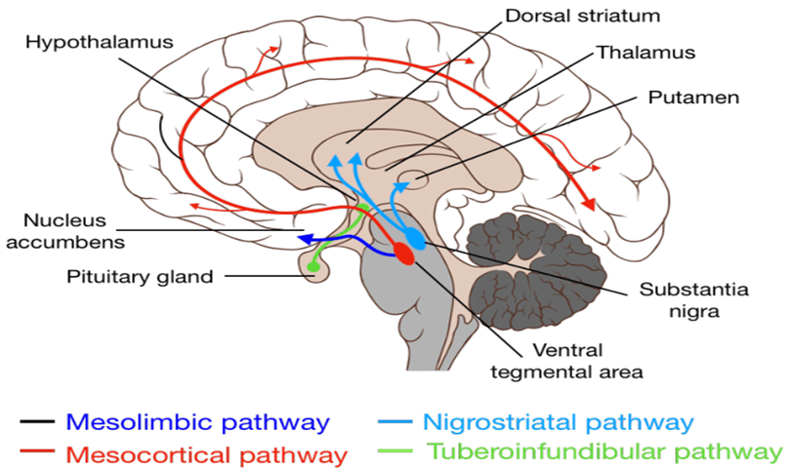
  - D2, D3, D4: Inhibitory (e.g., ↓ Ca2+ presynaptically, ↑ K+ conductance postsynaptically, ↓ cAMP).
- Pharmacology: Antagonists for D1/D2 include Phenothiazines, for D2 also Butyrophenones.

3. Gamma-aminobutyric acid (GABA)
- Role: Chief inhibitory neurotransmitter in the CNS and retina.
- Synthesis: Formed by the decarboxylation of glutamate, catalyzed by glutamate decarboxylase (GAD).
- Catabolism: Catabolized by GABA transaminase to succinic semialdehyde.
- Receptors:
  - Ionotropic (GABAA and GABAC): Directly linked to ion channels. GABAA receptor binding increases Cl- conductance, leading to inhibitory postsynaptic potentials. Antagonists include Bicuculline.
  - Metabotropic (GABAB): G protein-coupled receptors that open K+ channels via intermediaries. Inhibitory (e.g., ↓ Ca2+ conductance presynaptically, ↑ K+ conductance postsynaptically). Antagonist is 2-OH saclofen.

4. Glutamate
- Role: Most commonly found excitatory neurotransmitter in the brain.
- Functions: Involved in cognition, memory, and learning.
- Synthesis: Formed from α-ketoglutarate, an intermediate of the Krebs cycle.
- Receptors:
  - Ionotropic (NMDA, AMPA, Kainate): All excitatory by increasing cation conductance (NMDA particularly Ca2+). Antagonists for AMPA include NBQX, for Kainate include ACET.
  - Metabotropic: Can be inhibitory (presynaptic, e.g., ↓ Ca2+ conductance, ↓ cAMP) or excitatory (e.g., ↓ K+ conductance, ↑ IP3, DAG). Antagonist is MCPG.

5. Glycine
- Role: Non-essential amino acid; an inhibitory neurotransmitter in the CNS, especially in the spinal cord, brainstem, and retina.
- Mechanism: Activation of glycine receptors leads to Cl- entry via ionotropic receptors, causing inhibitory postsynaptic potentials (IPSP).
- Antagonist: Strychnine is an antagonist at ionotropic glycine receptors.

6. Serotonin (5-Hydroxytryptamine, 5-HT)
- Synthesis: Synthesized from the essential amino acid tryptophan (with help from vitamin B6 and carbohydrates).
- Distribution: Extensively synthesized in the gastrointestinal tract (90%) and stored in blood platelets.
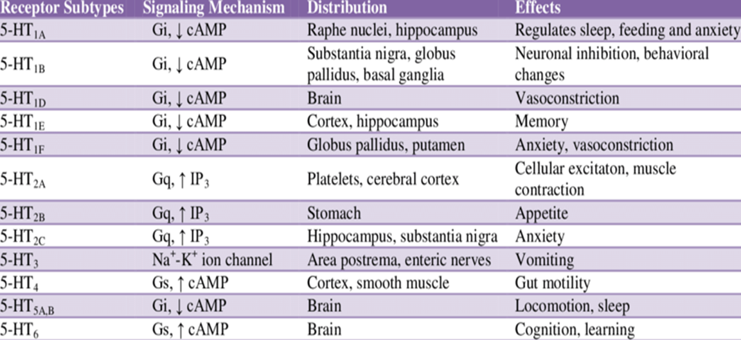
- Receptors: Diverse family of receptors (5-HT1A, 5-HT2A, 5-HT3, 5-HT4, etc.) with varied mechanisms (inhibitory via ↑ K+ conductance, ↓ cAMP; excitatory via ↓ K+ conductance, ↑ IP3, DAG; excitatory via ↑ cation conductance).

7. Norepinephrine (NE)
- Classification: Catecholamine.
- Release: Released from the adrenal medulla as a hormone into blood and as a neurotransmitter in the CNS and sympathetic nervous system.
- Functions: Major stress hormone associated with "fight-or-flight" response, increasing heart rate, glucose release, and skeletal muscle readiness.
- Receptors:
  - Alpha (α1, α2): α1 is excitatory (↓ K+ conductance, ↑ IP3, DAG). α2 is inhibitory (presynaptic: ↓ Ca2+ conductance; postsynaptic: ↑ K+ conductance, ↓ cAMP).
  - Beta (β1, β2): Both excitatory (β1: ↓ K+ conductance, ↑ cAMP) and inhibitory (β2: may involve ↑ electrogenic sodium pump, ↑ cAMP).

8. Histamine
- Role: Biogenic amine involved in local immune responses, regulating gut physiological function, and acting as a neurotransmitter.
- Synthesis: Synthesized from histidine.
- Degradation: Broken down by acetaldehyde dehydrogenase (deficiency triggers allergic reaction), histamine-n-methyltransferase, and diamine oxidase.
- Receptors: H1, H2, H3. H1 and H2 are excitatory (↓ K+ conductance, ↑ IP3, DAG for H1; ↓ K+ conductance, ↑ cAMP for H2). H3 are inhibitory autoreceptors.
Neuromodulators and Other Important Messengers

9. Opioid Peptides
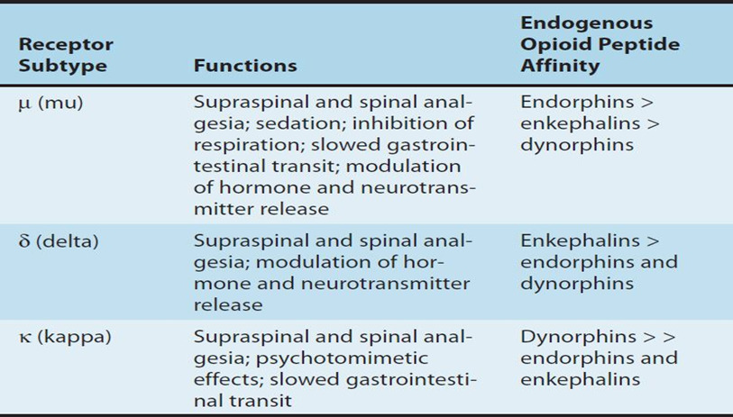
- Examples: Endorphins and dynorphins.
- Role: Neuromodulators that modify actions of other neurotransmitters by altering electrical properties of target neurons, making them harder to excite, influencing neurotransmitter release.
- Functions: Induce pain relief and euphoria, affect behaviors like alcohol consumption (alcohol can activate the opioid peptide system).
- Receptors: Mu, Delta, Kappa. All are inhibitory (Mu: ↓ Ca2+ conductance, ↓ cAMP; Delta/Kappa: ↑ K+ conductance, ↓ cAMP).

10. Orexins
- Classification: Peptide neurotransmitters.
- Location: Produced in neurons in the lateral and posterior hypothalamus, projecting widely throughout the CNS.
- Mechanism: Released from large, dense core vesicles, binding to two G protein-coupled receptors (OX1 and OX2). Orexin neurons also co-release glutamate, making them excitatory.
- Functions: Promote wakefulness (lack causes narcolepsy and disrupted sleep-wake patterns), involved in energy homeostasis, feeding behaviors, autonomic function, and reward.

11. Substance P
- Function: Well-known as a neurotransmitter and modulator of pain perception, altering cellular signaling pathways.
- Other Roles: Involved in gastrointestinal functioning, memory processing, angiogenesis, vasodilation, and cell growth/proliferation.
- Pain Mechanism: Intense noxious stimulation can induce Substance P release into the dorsal horn, leading to central hyperexcitability and increased pain sensitivity.

13. Endocannabinoids
- Mechanism: Endogenous cannabinoids (like anandamide) act as retrograde synaptic messengers. Released from postsynaptic neurons, they travel backward to activate CB1 receptors on presynaptic neurons, suppressing transmitter release (transient or long-lasting).
- Impact: Affect memory, cognition, and pain perception.
- Psychoactive Component: 9-tetrahydrocannabinol (9-THC) in cannabis affects the brain by activating the CB1 receptor.
- Receptors: CB1 (widely distributed). Inhibitory (presynaptic: ↓ Ca2+ conductance, ↓ cAMP).

14. Nitric Oxide (NO)
- Synthesis: Substantial amount of nitric oxide synthase (NOS) in certain neurons in the CNS. Neuronal NOS is activated by calcium-calmodulin, often through NMDA receptor activation (increasing intracellular calcium).
- Role: Primary inhibitory neurotransmitter (along with ATP/purines).
- Mechanism: NO diffuses across the cell membrane to bind guanylyl cyclase, activating intracellular mechanisms leading to muscle relaxation.

15. Neuropeptide Y (NPY)
- Structure: 36 amino acid peptide neurotransmitter.
- Location: Found in the brain and autonomic nervous system.
- Functions: Increases vasoconstrictor effects of noradrenergic neurons.

16. Purines (Adenosine, ATP, UTP, UDP)
- Distribution: Receptors found throughout the body, including the CNS.
- ATP: High concentrations in and released from catecholinergic synaptic vesicles; can be converted to adenosine extracellularly.
- Adenosine in CNS: Acts on metabotropic A1 receptors. Presynaptic A1 receptors inhibit calcium channels and inhibit the release of both amino acid and monoamine transmitters.
- Physiological Roles: Involved in memory, wakefulness, and appetite; may play roles in neuropsychiatric disorders.
Neurotransmitters are chemicals that transmit signals directly across synapses, typically producing fast excitatory or inhibitory effects via ionotropic or metabotropic receptors.

